RESUME SEARCH AND CANDIDATE SCREENING SYSTEM
A Project Report
Submitted in partial fulfillment of the requirements for the award of the degree of
BACHELOR OF TECHNOLOGY
in
DEPARTMENT OF COMPUTER SCIENCE ENGINEERING
by
L. ASHMITHA REDDY : 2520030061
A. NAGAJYOTHI : 2520030208
K. HARIKA : 2520030397
Under the Guidance of
Dr. V. Sireesha
Professor
Department of Computer Science and Engineering
2026–27

DEPARTMENT OF COMPUTER SCIENCE ENGINEERING

DECLARATION
We hereby declare that the project report entitled “Resume Search and Candidate Screening System” is a record of the work carried out by us as part of the academic mini project in the Department of Computer Science Engineering.
The project was developed as a practical application of string processing, searching, similarity measurement, ranking and data handling techniques. The implementation, testing and observations presented in this report are based on the project files and dataset used during development.
We further declare that this report is prepared for academic submission and that the work has not been submitted elsewhere for the award of any other degree or qualification.
Student Name | ID | Signature
L. ASHMITHA REDDY | 2520030061 | ________________
A. NAGAJYOTHI | 2520030208 | ________________
K. HARIKA | 2520030397 | ________________

DEPARTMENT OF COMPUTER SCIENCE ENGINEERING

CERTIFICATE
This is to certify that the project report entitled “Resume Search and Candidate Screening System” is a bonafide work done and submitted by L. ASHMITHA REDDY – 2520030061, A. NAGAJYOTHI – 2520030208 and K. HARIKA – 2520030397 in partial fulfillment of the requirements for the award of the degree of BACHELOR OF TECHNOLOGY in Computer Science Engineering during the academic year 2026–27.
The work presented in this report was carried out under the guidance of Dr. V. Sireesha, Professor, Department of Computer Science and Engineering.
Signature of the Guide | Signature of the HOD
________________________ | ________________________
Dr. V. Sireesha | Dr. P. Venkateswara Rao

ACKNOWLEDGEMENT
We would like to express our sincere gratitude to everyone who supported us during the development of our project, “Resume Search and Candidate Screening System”. Working on this project helped us connect the concepts studied in our courses with a practical problem that occurs in real recruitment workflows.
We are especially thankful to our guide, Dr. V. Sireesha, Professor, Department of Computer Science and Engineering, for her guidance, suggestions and encouragement throughout the development of the project. Her feedback helped us improve the organization of the system and understand how different algorithmic techniques could be combined instead of treating them as separate classroom exercises.
We also thank Dr. P. Venkateswara Rao, Associate Professor and Head of the Department of Computer Science and Engineering, for providing the academic support and facilities required to complete the work. Finally, we thank our faculty members, classmates and everyone who directly or indirectly helped us test the application and complete this report.
L. ASHMITHA REDDY
A. NAGAJYOTHI
K. HARIKA

ABSTRACT
Recruitment teams often receive a large number of resumes for a single job opening. Manually reading every resume and checking whether a candidate has a required skill can take considerable time, especially when the same search has to be repeated for different skills. A simple keyword search also has a practical weakness: a small spelling mistake in the recruiter’s query may cause a relevant candidate to be missed.
The project “Resume Search and Candidate Screening System” was developed to address this problem through a Java-based command-line application that searches a structured resume dataset and presents matching candidates in a recruiter-friendly format. The system loads resume records from a CSV file and converts each record into an internal Resume object containing candidate details, education, experience and skills.
The search process is divided into exact and fuzzy stages. For exact matching, the system uses KMP, Rabin-Karp and Z-Algorithm implementations and checks the candidate skill field. When exact results are unavailable, the application performs fuzzy matching using Edit Distance and a percentage-based similarity calculation. Matching candidates are then assigned a final score using exact match, fuzzy match and similarity components and are ranked from higher to lower score.
The supplied project dataset contains 815 resume records and nine columns, including name, email, phone, university, graduation year, years of experience, job role, skills and resume text. During testing, an exact “Python” query returned 221 candidates, while the typo query “Pythn” returned 228 candidates through fuzzy matching. These results demonstrate the main practical benefit of the system: it can retain useful candidates even when the recruiter does not enter the skill name perfectly.
The project also contains independent implementations and test cases for additional algorithms such as Aho-Corasick, weighted edit distance, sequence alignment, suffix array, LCP/Kasai, bipartite matching and approximate selection. These components support the academic objective of studying advanced algorithms even though the main interactive search flow uses a smaller set of them.

TABLE OF CONTENTS
Section | Page No.
Acknowledgement | iv
Abstract | v
Table of Contents | vi
List of Figures | vii
1 Introduction | 1
1.1 Overview | 1
1.2 Problem Statement | 3
1.3 Scope of the Project | 4
1.4 Objectives | 5
2 System Requirements | 7
2.1 Functional Requirements | 7
2.2 Non-Functional Requirements | 9
3 System Design | 11
3.1 High-Level Architecture Diagram | 11
3.2 Description of Each Layer | 13
4 Implementation | 17
4.1 Module-wise Implementation | 17
4.2 Front-end / User Interaction Logic | 22
4.3 Data Loading and Parsing | 23
4.4 Search Algorithms | 25
4.5 Candidate Scoring and Ranking | 31
5 Results | 34
5.1 Test Cases | 34
5.2 Sample Outputs | 37
5.3 Discussion of Results | 39
6 Challenges & Limitations | 42
6.1 Issues Faced During Development | 42
6.2 Solutions Applied | 44
6.3 Limitations of the System | 46
7 Conclusion & Future Work | 48
7.1 Conclusion | 48
7.2 Future Work | 50
7.3 Skills Learned During Development | 52
References | 54

LIST OF FIGURES
Figure | Title | Page
1.1 | High-Level Architecture of the Resume Search and Screening System | 2
1.2 | Search and Candidate Screening Flow | 5
2.1 | Functional View of the System | 8
3.1 | Main Class-Level Design | 12
4.1 | Exact and Fuzzy Search Pipeline | 18
4.2 | Candidate Scoring Model | 32
5.1 | Sample Exact Search Output for Python | 37
5.2 | Sample Fuzzy Search Output for Pythn | 38

1. INTRODUCTION

1.1 Overview
Recruitment is a data-heavy activity. A recruiter may receive hundreds of resumes for one position, and the first screening stage usually involves checking whether a candidate has a set of required technical or professional skills. When this work is done manually, the recruiter has to repeatedly open resumes, scan skill lists, compare experience and decide which profiles deserve further attention.
The project developed by our team focuses on one specific part of this workflow: skill-based resume search and initial candidate screening. Instead of asking the recruiter to inspect every resume, the application accepts a required skill as input and searches the available resume records. It then displays candidate details such as name, candidate ID, email, phone number, education, experience, matched skills, match type, similarity and final score.
A key design decision in the project is to separate exact matching from fuzzy matching. Exact matching is useful when the recruiter enters a skill correctly. Fuzzy matching becomes useful when the query contains a minor spelling error, such as “Pythn” instead of “Python”. This makes the system more forgiving without removing the accuracy of direct matching.
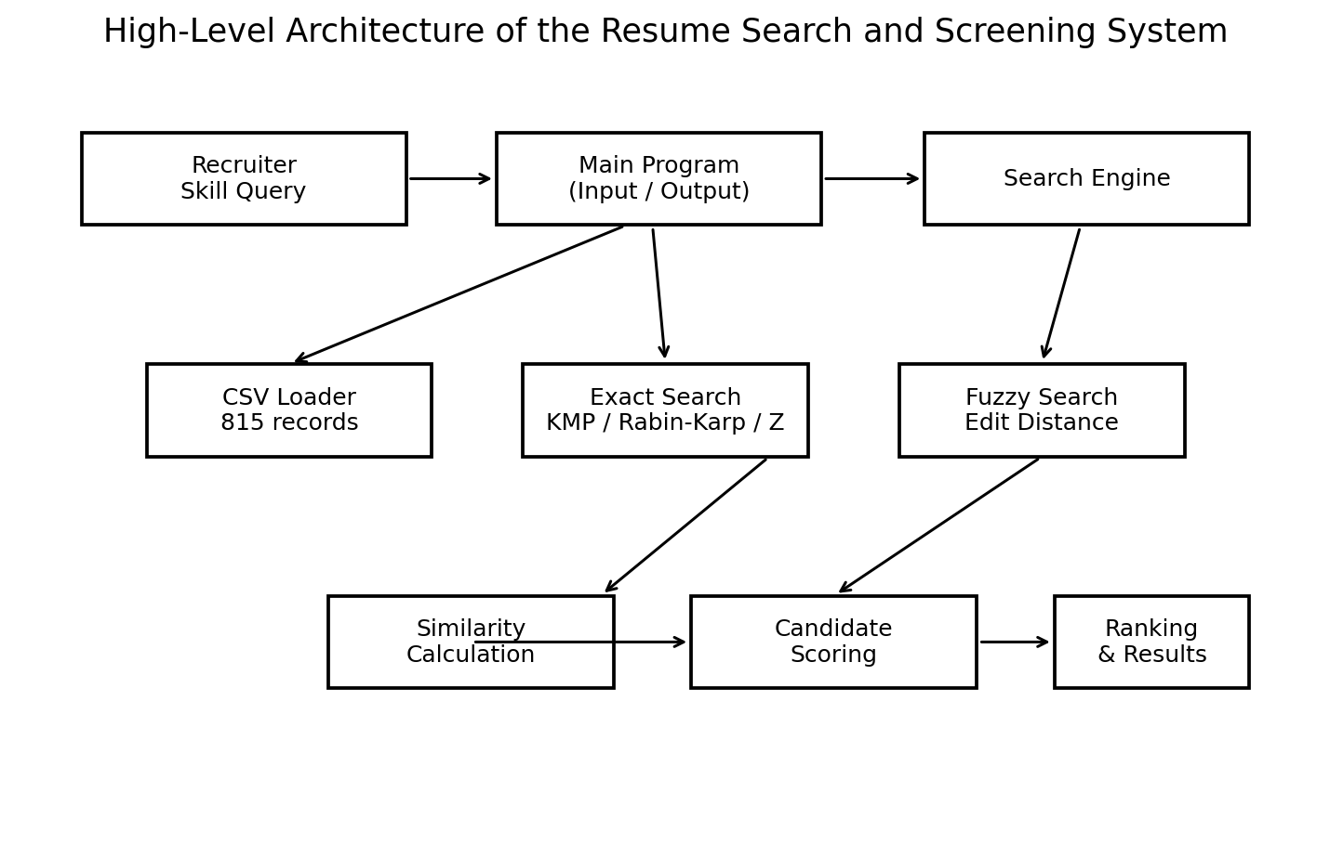
Fig. 1.1 High-Level Architecture of the Resume Search and Candidate Screening System

1.2 Problem Statement
Traditional manual resume screening becomes difficult as the number of applications increases. A recruiter may know exactly what skill is required, but finding that skill across a large collection of resumes is repetitive. A basic exact keyword search can also fail when there are small spelling differences between the query and the skill stored in a resume.
The problem addressed in this project can therefore be stated as follows: design and implement a lightweight candidate screening system that can load a structured resume dataset, search for required skills using efficient string matching techniques, tolerate small spelling variations through fuzzy matching, calculate a meaningful match score, and present candidates in ranked order.

1.3 Scope of the Project
- The system accepts a single required skill from the recruiter through the console.
- Resume data is loaded from a CSV file and converted into Resume objects.
- Exact skill matching is performed using KMP, Rabin-Karp and Z-Algorithm implementations.
- Fuzzy matching is used when exact matching does not return candidates.
- Edit Distance and percentage similarity are used to identify close skill names.
- Candidates are scored and ranked so that stronger matches appear first.
- The system displays relevant candidate and match information in a readable console format.
- The project also includes separate test implementations for advanced algorithms such as Aho-Corasick, weighted edit distance, sequence alignment, suffix array, LCP, bipartite matching and approximate selection.

1.4 Objectives
- To build a practical resume search application using Java.
- To represent resume information using structured objects rather than handling raw text throughout the program.
- To implement and compare multiple string matching techniques in the exact-search stage.
- To support typo-tolerant fuzzy matching using edit distance and similarity.
- To calculate a final candidate score and rank the matching profiles.
- To test the algorithms separately and verify the complete application with a real resume dataset.
- To present the search results in a form that is easy for a recruiter or evaluator to understand.

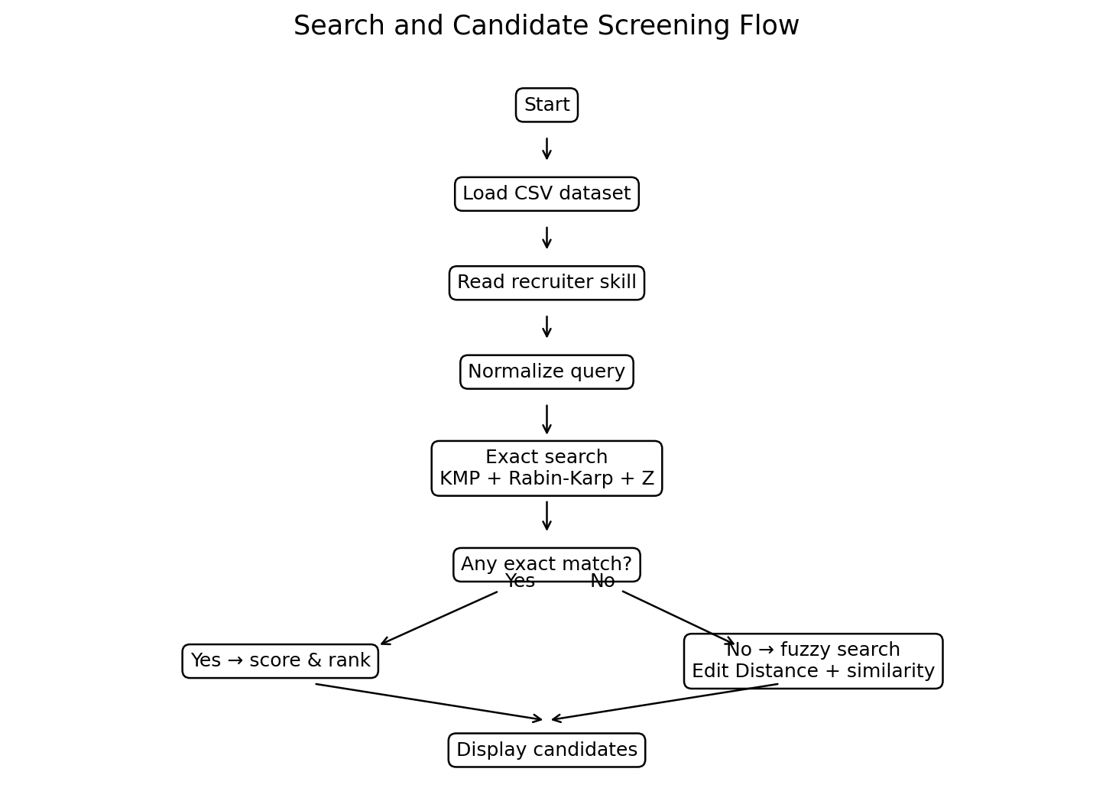
Fig. 1.2 Search and Candidate Screening Flow
The flow above reflects the actual control flow of the main application. The program first loads the dataset, asks for the required skill, normalizes the query, performs exact matching and checks whether any candidates were found. If exact matching produces no result, the system automatically switches to fuzzy matching. Finally, the resulting Candidate objects are scored, ranked and displayed.

2. SYSTEM REQUIREMENTS

2.1 Functional Requirements
Functional requirements describe what the system should do from the user’s point of view. The following requirements are directly reflected in the project implementation.
ID | Requirement | Description
FR1 | Dataset loading | The application must read resume records from the supplied CSV dataset.
FR2 | Input handling | The recruiter must be able to enter a required skill through the console.
FR3 | Query normalization | The entered skill is trimmed and converted to lowercase before searching.
FR4 | Exact search | The system must search candidate skills using exact string matching.
FR5 | Fuzzy search | If exact results are unavailable, the system must search for similar skill names.
FR6 | Similarity | The system must calculate the best similarity between the query and the candidate’s listed skills.
FR7 | Scoring | The system must calculate a final candidate score.
FR8 | Ranking | The system must arrange candidates by final score.
FR9 | Result display | The system must display candidate details and matching information.
FR10 | Empty query validation | The system must reject an empty skill query.

2.2 Non-Functional Requirements
Category | Requirement | Project Interpretation
Usability | Simple interaction | Console prompts guide the recruiter through the search.
Performance | Reasonable search time | String matching avoids repeatedly comparing complete resume documents unnecessarily.
Reliability | Graceful handling | The program checks for missing data and empty input.
Maintainability | Separate classes | Loading, searching, scoring, ranking and algorithms are implemented in separate classes.
Portability | Java-based execution | The project can be compiled and executed in a standard Java environment.
Readability | Recruiter-friendly output | Candidate information is printed using clear labels and separators.

2.3 Hardware and Software Environment
Item | Specification / Tool
Programming Language | Java
Input Dataset | resume_dataset_2.csv
Dataset Size | 815 resume records
CSV Fields | 9 fields
Execution Style | Command-line application
Development Structure | Java source files under src/
Data Structure | Arrays, strings and object-based records
Testing | AlgorithmTest.java and application-level execution

3. SYSTEM DESIGN

3.1 High-Level Architecture Diagram
Fig. 3.1 High-Level Architecture
The system follows a simple layered flow. At the input side, the recruiter supplies a skill query. The main program controls the interaction and sends the query to SearchEngine. CSVResumeLoader is responsible for converting the CSV records into Resume objects. SearchEngine performs exact or fuzzy matching, while Similarity, CandidateScorer and CandidateRanker support the decision-making part of the screening process.

3.2 Description of Each Layer

3.2.1 Input Layer
The input layer is implemented through the Scanner object in Main.java. The recruiter is asked to enter a required skill. The query is trimmed and converted to lowercase. An empty query is rejected so that the search engine does not perform meaningless work.

3.2.2 Data Layer
The data layer is handled mainly by CSVResumeLoader and Resume. CSVResumeLoader reads the CSV file, handles quoted fields and creates a Resume object for every valid record. Resume stores candidate ID, name, email, phone, skills, education, experience and project/resume text.

3.2.3 Search Layer
SearchEngine is the central processing component. It first performs exact search. For every resume, the skill text is searched using KMP, Rabin-Karp and Z-Algorithm. If at least one exact occurrence is found, the candidate is converted into a Candidate object and scored. If no exact candidate is returned, the fuzzy-search path checks individual skills using edit distance and similarity.

3.2.4 Scoring and Ranking Layer
CandidateScorer converts the matching information into a score between 0 and 100. Exact matching has the largest contribution, followed by fuzzy matching and similarity. CandidateRanker then orders the Candidate array using a selection-sort style approach, placing the highest final score first.

3.2.5 Presentation Layer
Main.java presents the final result. The output contains the required skill, number of candidates, candidate details, matched skills, match type, similarity percentage and final match score. This makes the result understandable without requiring the user to inspect internal algorithm values.
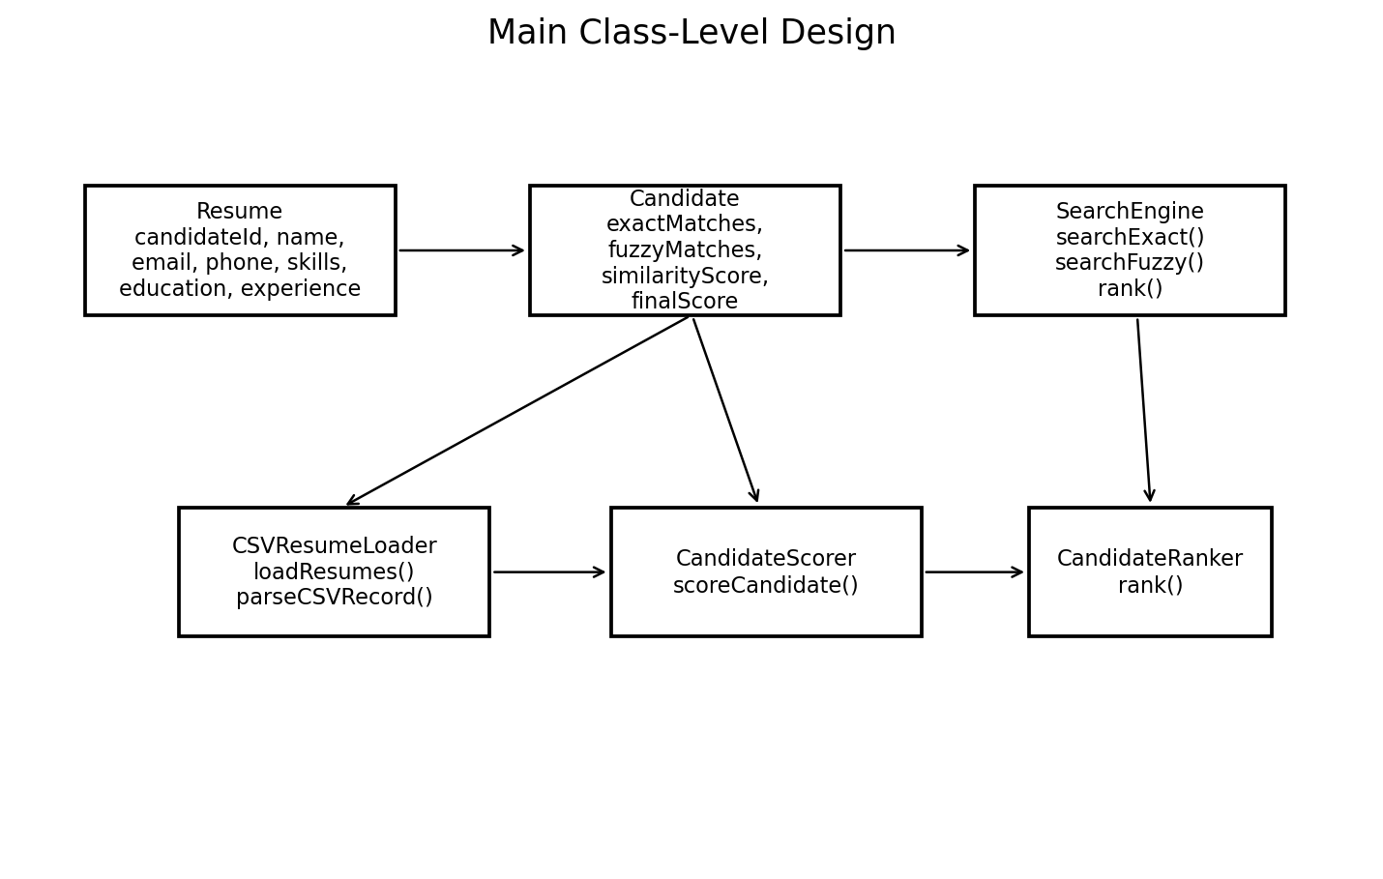
Fig. 3.2 Main Class-Level Design

4. IMPLEMENTATION

4.1 Module-wise Implementation

4.1.1 Main Module
Main.java controls the complete interaction. It loads the CSV dataset, accepts the skill query, invokes SearchEngine and prints the results.

4.1.2 Resume Model
Resume.java represents one candidate record and provides getter methods for candidate information.

4.1.3 CSV Loading Module
CSVResumeLoader.java reads the nine-column dataset and converts each row into a Resume object. It also handles quoted CSV records and embedded line breaks.

4.1.4 Search Engine Module
SearchEngine.java provides searchExact() and searchFuzzy(). It also builds the final candidate array and invokes ranking.

4.1.5 Similarity Module
Similarity.java calculates a percentage similarity from edit distance and can find the best skill similarity within a comma-separated skills list.

4.1.6 Candidate Scoring Module
CandidateScorer.java combines exact matches, fuzzy matches and similarity into a final score.

4.1.7 Candidate Ranking Module
CandidateRanker.java arranges Candidate objects in descending order of final score.

4.1.8 Algorithm Test Module
AlgorithmTest.java provides individual tests for multiple advanced algorithms included in the project.

4.2 Front-end Logic (User Interaction)
Although the project does not use a graphical web front end, the console interface acts as the user-facing layer. The interaction was deliberately kept simple because the main purpose of the project is algorithmic candidate search rather than interface design.
RESUME SEARCH & CANDIDATE SCREENING
Enter Required Skill: Python
Searching resumes...
Please wait...
SEARCH RESULTS
Required Skill : python
Candidates Found : 221
After the search is completed, each candidate is shown using clearly labelled fields. The system also cleans phone values ending in “.0”, which is useful because numeric phone values in CSV files can sometimes be represented in that form.

4.3 Data Loading and Parsing
The project dataset contains 815 records and nine columns: Name, Email, Phone, University, Graduation_Year, Years_Experience, Job_Role, Skills and Resume_Text. CSVResumeLoader skips the header and reads each logical CSV record. The parser tracks quotation marks so that commas inside quoted resume text are not incorrectly treated as field separators.
For every row, university and graduation year are combined into the Education field. Years of experience and job role are combined into the Experience field. The original resume text is retained in the project/resume-text field of the Resume object.

4.4 Search Algorithms

4.4.1 KMP (Knuth-Morris-Pratt)
KMP searches for a pattern by preprocessing the pattern into an LPS (Longest Prefix which is also Suffix) array. When a mismatch occurs, the algorithm uses the LPS information to avoid restarting the comparison from the beginning of the pattern. In this project, KMP is used as one of the exact matching checks over the candidate skill text.

4.4.2 Rabin-Karp
Rabin-Karp uses a rolling hash. The project calculates a hash for the query and for a window of the skill text. When the hashes match, the characters are checked to avoid accepting a hash collision as a real match. The implementation uses BASE = 256 and PRIME = 101.

4.4.3 Z-Algorithm
The Z-Algorithm builds a Z array that records how many characters from each position match the prefix of the combined string. The project combines pattern, a separator and text, then checks Z values to count occurrences of the pattern.

4.4.4 Aho-Corasick
Aho-Corasick is implemented as a separate component for multi-pattern searching. It constructs a trie and failure links so several patterns can be searched in one pass. The AlgorithmTest class verifies the implementation using patterns such as Java, Python and SQL.

4.4.5 Edit Distance
Edit Distance uses dynamic programming to find the minimum number of insertions, deletions and replacements required to transform one string into another. It is important in this project because a query such as “Pythn” is close to “Python” even though it is not an exact string match.

4.4.6 Weighted Edit Distance
The project also contains WeightedEditDistance. In this version, insertion and deletion have a cost of 2, while a replacement has a cost of 3. Matching characters have zero replacement cost. This provides an additional way to experiment with the effect of different edit penalties.

4.4.7 Sequence Alignment
SequenceAlignment uses dynamic programming with match, mismatch and gap scores. The current implementation uses a match score of 2, mismatch penalty of -1 and gap penalty of -2. It is included as an advanced similarity technique in the algorithm test suite.

4.4.8 Suffix Array and LCP
SuffixArray constructs an ordered list of suffix starting positions. LCP/Kasai then calculates the longest common prefix between neighbouring suffixes. These components are not part of the main interactive search path, but they demonstrate additional indexing and string-processing techniques.

4.4.9 Bipartite Matching and Approximate Selection
BipartiteMatching and ApproximateSelection extend the project toward candidate-to-requirement assignment and top-candidate selection. The separate AlgorithmTest class demonstrates these components with small controlled examples.

4.5 Exact Search and Fuzzy Search Logic
The exact search path checks the skills field of every Resume object. KMP is used to determine whether the query occurs. When an exact match is found, Rabin-Karp and Z-Algorithm are also evaluated, and the maximum reported occurrence count is stored as the exact-match count for scoring.
If exact search returns no candidates, SearchEngine.searchFuzzy() splits each candidate’s skill field into individual skills. It calculates edit distance and similarity for each skill. A skill is considered a fuzzy match when the edit distance is at most 2 or the similarity is at least 60 percent.
if (distance <= 2 || similarity >= 60.0) {
fuzzyMatches++;
}
This rule gives the application a practical balance: it accepts small spelling differences while avoiding extremely unrelated skill names. The best similarity found among the candidate’s skills is retained as the candidate similarity score.

4.6 Candidate Scoring
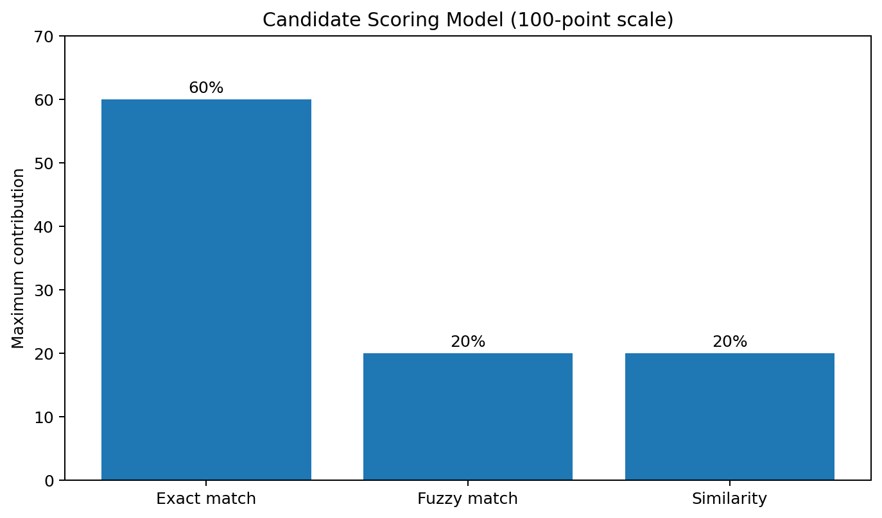
Fig. 4.1 Candidate Scoring Model
The project uses a 100-point scoring model. The exact-match component can contribute up to 60 points, the fuzzy-match component up to 20 points and the similarity component up to 20 points. The score is then limited to the range 0–100 and rounded to two decimal places.
exactPart = min(exactMatches, 1) * 60
fuzzyPart = min(fuzzyMatches, 1) * 20
similarityPart = similarityScore * 0.20
finalScore = exactPart + fuzzyPart + similarityPart
The design gives the strongest importance to an exact skill match. This is appropriate for a first-stage screening system because a recruiter normally wants direct evidence that the candidate lists the required skill. Similarity still contributes to the score and becomes particularly important for fuzzy results.

4.7 Candidate Ranking
After the Candidate array is created, CandidateRanker.rank() sorts it in descending order of final score. The implementation uses a selection-sort style process: for each position, it searches the remaining candidates for the highest score and swaps that candidate into the current position.

4.8 Algorithm Testing
AlgorithmTest.java was created to test the individual algorithms independently. This is useful because a correct overall application result does not automatically prove that every supporting algorithm behaves correctly. The test class checks KMP, Rabin-Karp, Z-Algorithm, Aho-Corasick, Edit Distance, Weighted Edit Distance, Sequence Alignment, Suffix Array, LCP/Kasai, Bipartite Matching and Approximate Selection.
[1] KMP
Occurrences of java: 2
[2] Rabin-Karp
Occurrences of java: 2
[3] Z Algorithm
Occurrences of java: 2
[5] Edit Distance
python vs pythn: 1

5. RESULTS

5.1 Test Cases
Test ID | Input | Expected Behaviour | Observed Result
TC01 | Python | Find exact skill matches | 221 candidates returned
TC02 | Pythn | Use fuzzy matching for typo | 228 candidates returned
TC03 | Empty input | Reject search and show validation message | Search is stopped
TC04 | Java algorithm test | Count occurrences in sample text | 2 occurrences
TC05 | python vs pythn | Calculate edit distance | Distance = 1
TC06 | No matching skill | Show no-match message | Application supports no-match path

5.2 Sample Output – Exact Search
When the recruiter enters “Python”, the application finds candidates whose skills contain the required skill. The dataset contains 221 such candidate records in the tested execution.
============================================================
SEARCH RESULTS
============================================================
Required Skill : python
Candidates Found : 221
------------------------------------------------------------
Candidate 1
------------------------------------------------------------
Name : Tara Gonzalez
Candidate ID: CSV-1
Email : deborah75@example.com
Phone : 8371518054
Education : Jadavpur University | Graduation Year: 2018
Experience : 3 years | Role: Data Scientist
Skills Matched:
- Python
Match Type : Exact Match
Similarity : 100.0%
Match Score : 80.0

5.3 Sample Output – Fuzzy Search
The typo query “Pythn” demonstrates the main advantage of the fuzzy search path. No exact “Pythn” skill is expected in the dataset, so the application compares the query with individual skills. “Python” is close enough to pass the edit-distance/similarity condition, resulting in 228 candidates in the tested execution.
Required Skill : pythn
Candidates Found : 228
Candidate 1
Name : Tara Gonzalez
Candidate ID: CSV-1
Education : Jadavpur University | Graduation Year: 2018
Experience : 3 years | Role: Data Scientist
Skills Matched:
- Python
Match Type : Fuzzy Match
Similarity : 83.33%
Match Score : 36.67

5.4 Discussion of Results
The test results show that the system is able to handle both normal and imperfect recruiter input. The exact search returns a large set of candidates for a common skill, while the fuzzy search retains candidates when the query contains a small spelling mistake. This is a useful behaviour for a screening tool because human users do not always type skill names exactly as they appear in a dataset.
The results also show the importance of ranking. A search result list is more useful when stronger matches appear first rather than being displayed in arbitrary dataset order. The Candidate object stores the values needed for this ranking, including exact matches, fuzzy matches, similarity and final score.
The application is intentionally a first-stage screening tool. It does not claim to make a final hiring decision. Instead, it reduces the amount of manual searching required and gives the recruiter a structured shortlist that can be reviewed further.

6. CHALLENGES & LIMITATIONS

6.1 Issues Faced During Development
One of the practical difficulties was handling the CSV dataset correctly. Resume text and other fields can contain commas, so simply splitting every line on commas can create incorrect columns. The CSVResumeLoader therefore checks whether quotation marks are balanced and uses a custom parser that only treats commas outside quoted sections as separators.
Another challenge was deciding how exact and fuzzy matching should work together. If fuzzy matching were always applied, the system could return many loosely related skills. The final implementation therefore gives priority to exact search and only falls back to fuzzy search when exact search returns no candidates.
A further challenge was representing the candidate score in a way that was easy to explain. The final score uses three components with clear maximum contributions: exact match, fuzzy match and similarity. This makes the result easier to interpret than a score produced by an unexplained formula.
Testing many algorithms separately also required small controlled examples. AlgorithmTest.java provides these examples so that each algorithm can be checked independently before relying on it as part of the overall project.

6.2 Solutions Applied
- Implemented a custom CSV record reader that supports quoted and multi-line records.
- Separated data loading, search, scoring and ranking into different classes.
- Normalized search queries to lowercase and removed unnecessary surrounding spaces.
- Used exact matching as the first stage and fuzzy matching as a fallback.
- Used edit distance and percentage similarity together rather than relying on only one fuzzy condition.
- Added an independent algorithm test class for controlled verification.
- Formatted console output so that recruiters can quickly identify candidate information.

6.3 Limitations of the System
- The current application is console-based and does not provide a graphical or web interface.
- The system currently accepts one required skill at a time in the main interactive flow.
- The CSV dataset is loaded into memory, so very large datasets would require additional memory-management or indexing strategies.
- The current ranking score focuses mainly on the required skill and similarity. It does not perform a complete semantic evaluation of education, projects or job responsibilities.
- The fuzzy threshold is rule-based. Different job roles may require different thresholds.
- The system is intended for screening support and should not be treated as an autonomous hiring decision system.

7. CONCLUSION & FUTURE WORK

7.1 Conclusion
The Resume Search and Candidate Screening System successfully demonstrates how classical string algorithms and similarity techniques can be combined into a practical application. The project moves beyond a simple keyword search by providing a two-stage exact/fuzzy workflow, candidate scoring and ranking.
The implementation also helped us understand the difference between learning an algorithm in isolation and using it as part of a complete system. KMP, Rabin-Karp and Z-Algorithm are not presented merely as theoretical algorithms; they are used in the exact search stage. Edit Distance and similarity are then used to make the system more tolerant of imperfect input.
The supplied dataset contains 815 resume records, giving the project a realistic enough workload for demonstration. The tested “Python” search returned 221 candidates, while the typo-tolerant “Pythn” search returned 228 candidates. These observations confirm that the system performs its intended search and fallback behaviour.
Overall, the project provides a clear foundation for an automated recruitment support tool. It reduces repetitive searching and organizes candidate information in a structured way, while still leaving the final judgement to the recruiter.

7.2 Future Work
- Develop a web-based interface where recruiters can enter job requirements and view ranked candidates in a dashboard.
- Support multiple required skills in one search and calculate an overall job-fit score.
- Add weighting for experience, education, projects and job role along with skills.
- Introduce indexing structures so that very large resume collections can be searched without scanning every record.
- Add semantic skill matching so that related technologies and synonyms can be recognized.
- Allow resume files such as PDF and DOCX to be uploaded and parsed automatically.
- Store recruiter searches and shortlisted candidates in a database.
- Add configurable scoring thresholds for different job roles.
- Provide charts and analytics such as skill frequency, candidate distribution and shortlist statistics.
- Add fairness and audit features so that the screening process can be reviewed for unintended bias.

7.3 Skills Learned During Development
- Practical implementation of classical string matching algorithms.
- Dynamic programming for edit distance and sequence alignment.
- CSV parsing and structured data handling in Java.
- Object-oriented design using separate model and service classes.
- Designing scoring and ranking logic for a practical application.
- Debugging and testing algorithms with controlled input cases.
- Connecting algorithmic concepts with a real-world recruitment problem.
- Technical documentation and presentation of software project results.

8.OUTPUT
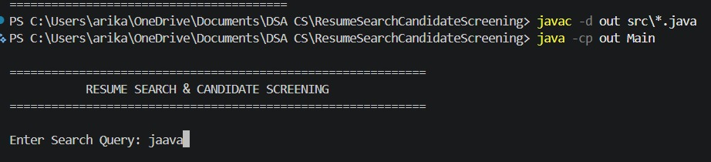

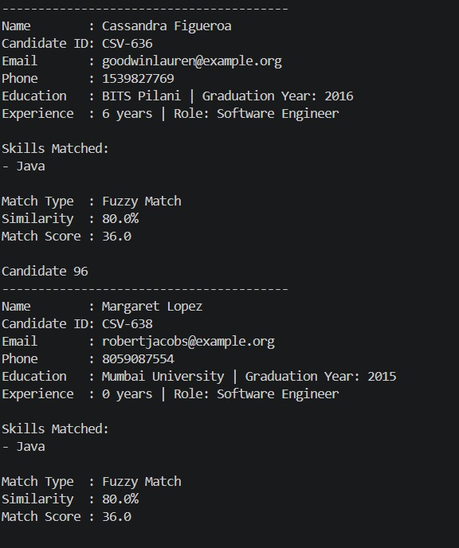

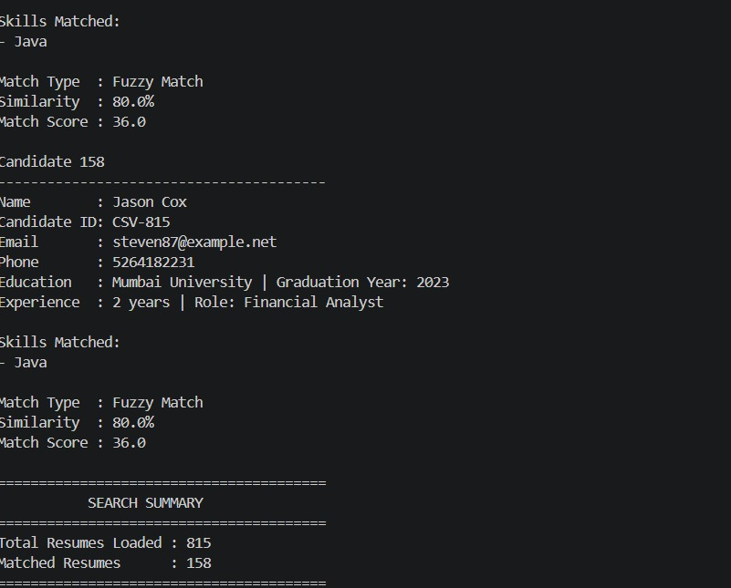

REFERENCES
[1] Project source code, “Resume Search and Candidate Screening System,” Java source files supplied with the project.
[2] Project dataset, “resume_dataset_2.csv,” supplied with the project, containing 815 resume records.
[3] T. H. Cormen, C. E. Leiserson, R. L. Rivest and C. Stein, Introduction to Algorithms, MIT Press.
[4] R. Sedgewick and K. Wayne, Algorithms, Addison-Wesley.
[5] Java Platform documentation, Java SE API documentation for standard input, strings, arrays and file handling.
[6] D. E. Knuth, J. H. Morris and V. R. Pratt, work on efficient pattern matching and the Knuth-Morris-Pratt algorithm.
[7] R. M. Karp and M. O. Rabin, work on efficient randomized pattern matching using hashing.
[8] Project file AlgorithmTest.java, used for independent verification of the implemented algorithms.

APPENDIX A – PROJECT STRUCTURE
ResumeSearchCandidateScreening/
├── dataset/
│ └── resume_dataset_2.csv
├── input/
├── output/
├── resumes/
├── src/
│ ├── Main.java
│ ├── Resume.java
│ ├── Candidate.java
│ ├── CSVResumeLoader.java
│ ├── SearchEngine.java
│ ├── CandidateScorer.java
│ ├── CandidateRanker.java
│ ├── Similarity.java
│ ├── EditDistance.java
│ ├── KMP.java
│ ├── RabinKarp.java
│ ├── ZAlgorithm.java
│ ├── AhoCorasick.java
│ ├── WeightedEditDistance.java
│ ├── SequenceAlignment.java
│ ├── SuffixArray.java
│ ├── LCPArray.java
│ ├── BipartiteMatching.java
│ ├── ApproximateSelection.java
│ └── AlgorithmTest.java
└── ...
The project structure shows that the implementation is divided into reusable Java classes. The main application is supported by independent algorithm classes and a separate test class, making the project easier to understand and extend.

APPENDIX B – ALGORITHM SUMMARY
Algorithm / Component | Purpose in Project | Typical Strength
KMP | Exact skill search | Avoids unnecessary pattern re-comparisons
Rabin-Karp | Exact skill verification | Uses rolling hash for pattern windows
Z-Algorithm | Exact occurrence counting | Linear-time prefix-based matching
Aho-Corasick | Multi-pattern test | Searches several patterns through a trie
Edit Distance | Fuzzy skill matching | Measures minimum edit operations
Weighted Edit Distance | Alternative fuzzy measure | Uses different operation costs
Sequence Alignment | String similarity experiment | Scores matches, mismatches and gaps
Suffix Array | String indexing experiment | Orders suffix starting positions
LCP / Kasai | Suffix similarity experiment | Finds common prefixes
Bipartite Matching | Skill-candidate assignment experiment | Finds maximum matching
Approximate Selection | Top candidate selection | Selects highest-scoring indexes

